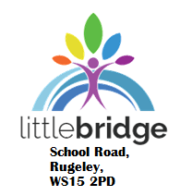

Friday 19th June, 2020

Dear Parents & Carers,

Positive Start back!

It has been absolutely fantastic to see so many of our learners over the past couple of weeks. Some of our Year 6 students have been attending our Little Bridge site since June 1st and have enjoyed engaging with the staff and friends again. Similarly at our Secondary site in Lichfield, Year 10 and Year 11 learners have been attending at allocated times this week to get some face-to-face contact with their teachers. All of the learners who have attended are definitely benefiting from this time in Centre. There have been some really productive meetings with Year 11 learners to support them in their career choices for post-16 as well as re-establishing those positive relationships with Year 10.

I would like to thank all learners and their families for their continued co-operation and support in these uncertain times. We are working hard to try and increase the offer to learners over the coming couple of weeks and also plan as much as we can for a safe return in September. I hope you are all well and staying safe – please do not hesitate to get in touch if you need anything

With Kindest Regards

Andrew Burton

Executive Headteacher

